Step one split image into 3 channels b,g,r, respectively.

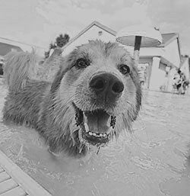

Display channels in respective colors.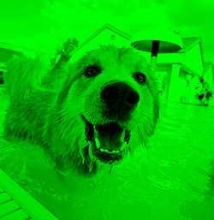

Merge channels back together for 3D image.

